

OpenServer Release 6

The Most Reliable Operating System
Just Got More Powerful

REVIEWER’S GUIDE

Table of Contents

Reviewer’s Guide Note 3
Summary of Contents 3
Disclaimer 3

Company Overview 4

Product Introduction 5
Built for Productivity 5
Built for Security 6
Built for Agility 6
Built to Protect Your Investment 6
Value Proposition 5

Features & Benefits 7
New Features and Benefits 7

System Requirements 11
Technical Overview 11
System Requirements 11
Hardware Requirements 12

Getting Started 14
SCO OpenServer Release 6 Installation Overview 14
To Install SCO OpenServer 6: 14
OpenServer KDE 23
Java (Web Application) Support 25
Encrypted File Systems 26
1 TeraByte File Support 28

Pricing and Support 29
New Optional Bundled Support 29
Global Services and Support 30
Technical Support 30
Professional Services 31
Online Support Services 31

More Information 32
Press Contact 32

Competitive Advantage 33
Microsoft 33
Red Hat and SuSE Linux 33
Other UNIX Flavors 33

Target Markets 35
Target Environments 35
Vertical Market Considerations 35
Primary Target 35
Target Problems Solved 36
Target Users 36
Target Channels 36
Language Support 37

Key Messages 38

Reviewer’s Guide Note
Thank you for your interest in reviewing SCO OpenServer 6 software. This guide will provide detailed information on the following areas:

- Company Overview
- Product Introduction
- Features & Benefits
- System Requirements
- Getting Started
- Pricing & Support
- Competitive Advantage
- Target Markets
- Key Messages

If you need any technical support for SCO OpenServer 6 during this product review, please contact SCO’s technical support staff at 888-826-7946. We will be happy to assist you with any of your technical support needs.

Summary of Contents
SCO has shipped all of the software needed to conduct a complete review of SCO OpenServer 6. To demonstrate the key features of the software in a working environment, the SCO OpenServer Reviewer’s Guide Packet will include the following:

- SCO OpenServer 6 software and documentation
- SCO OpenServer 6 Getting Started Guide
- This Reviewer’s Guide

Disclaimer
The SCO OpenServer Reviewer’s Guide is provided for informational purposes only, and the information herein is subject to change without notice. Please report any errors herein to SCO. SCO does not provide any warranties covering and specifically disclaims any liability in connection with this document. No part of this document may be copied or translated to another language without the express written consent of The SCO Group.

The SCO OpenServer Reviewer’s Guide and other SCO documents included are provided “as is” and may include technical inaccuracies or typographical errors. SCO reserves the right to add, delete, change, or modify SCO documents at any time without notice. The documents are for information purposes only. SCO makes no express or implied representations or warranties of any kind.

Copyright © 2005, SCO and the associated SCO logo are trademarks or registered trademarks of The SCO Group, Inc. in the U.S. and other countries. UNIX is a registered trademark of The Open Group. All other brand or product names are or may be trademarks of, and are used to identify products or services of, their respective owners.

Company Overview

The SCO Group, Inc. (NASDAQ: SCOX) is the owner of the UNIX® operating system and a leading provider of UNIX-based solutions. The company has developed and licensed innovative technologies for more than 25 years.

SCO is a provider of software solutions for small-to-medium-sized businesses (SMBs) and replicated branch offices. SCO solutions include UNIX platforms; e-mail and collaboration, messaging, authentication, and e-business tools; and services that include technical support, education, consulting, and solution provider support programs.

Based in Lindon, Utah, SCO helps millions of customers to grow their businesses everyday. SCO has a worldwide network of thousands of resellers and developers. SCO Global Services provides reliable localized support and services to partners and customers.

Headquarters
Nasdaq
Installed Base
Balance Sheet
Lindon, Utah
SCOX
2,000,000+ servers
$31.5 million in cash
$42.8 million
10,000
4,000
Offices and Representation in
Americas, Asia and EMEA
TTM Revenues
Global Reseller Program
ISV Developers
Global Sales

Product Introduction
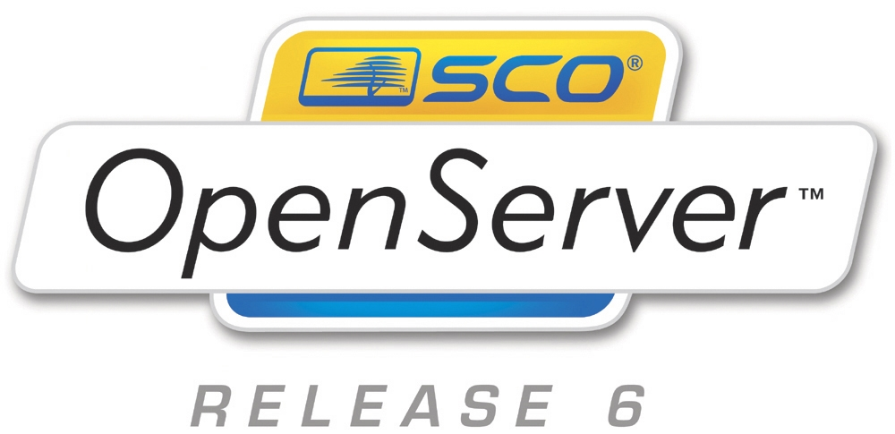
SCO OpenServer 6 delivers continued UNIX reliability to small-to-medium-sized businesses and branch offices. SCO OpenServer 6 has undergone impressive new modernization, including large file support, and support for a broader array of modern applications. With a decade of rock-solid stability and dependability, SCO
OpenServer has passed the test of time for businesses.
SCO OpenServer provides an affordable
all-in-one server to small-to-large businesses.
Out of the box, SCO OpenServer lets businesses
manage e-mail, simplify collaboration, protect
data with secure back-ups, connect a mobile work
force, and share high-speed Internet access. In addition, SCO OpenServer delivers a reliable platform for single certification enabling less work for ISVs and more applications for customers:

Value Proposition

- SCO OpenServer drives more reseller profits per system. In addition, SCO OpenServer has superior security, scalability, and reliability. Open industry standards increase compatibility and make it easier to integrate diverse applications and systems; open industry standards also provide vendor neutrality.
- SCO delivers complete operating systems that are stable, reliable and secure and have stood the test of time. A single, experienced vendor provides support, a dependable roadmap, and unencumbered intellectual property (IP).
- SCO OpenServer Release 6 provides a powerful new kernel with SVR5 technology enabling the development partner to port their modern application to OpenServer 6 taking advantage of large file support, multi-level threading, increased memory support, Java support, as well as updated Samba and Apache. This new modernization effort brings power and reliability to the end user and opens a broader market to the developer.
- Single certification allows ISVs to certify to one common kernel; DDI interface-compliant drivers will work on both UnixWare 7x as well as OpenServer 6.

For SCO customers, OpenServer Release 6 is:

Built for Productivity
Companies invest in IT solutions to improve speed, communication and productivity throughout their business. Not only does the system administrator need solutions that are easy to manage, deploy, and support, but the businesses’ employees need the tools necessary to improve their own productivity. Employees need powerful solutions that are easy to use.

Built for Security
Businesses are built on reliability and stability. SCO OpenServer 6 helps customers run their businesses on the most secure operating system for UNIX-on-Intel. Identity theft is ever increasing, and viruses constantly attempt to invade business operations. SCO’s customers rely on SCO’s UNIX platform to provide the high level of security needed in a demanding, fast transaction business. Businesses need systems that are always up and always responsive, and they demand a level of security able to meet customer demands. SCO OpenServer Release 6 includes new features and improvements that make it the most dependable UNIX-on-Intel platform available on the market.

Built for Agility
Businesses evolve with changing technologies. As new technologies are developed, businesses can improve their performance and profit. At SCO, we have been listening to customers’ needs and developing new technologies to adapt to the changing way in which businesses and IT managers run their business. Businesses today need instant information on new, mobile devices and clients. Stronger business collaboration tools enable business managers to make more intelligent decisions at a faster pace. With the increasing mobile nature of business, strong server support is necessary to serve up instant information to a mobile workforce.

Built to Protect Your Investment
SCO recognizes the significant investment companies make in their hardware and software IT solutions. With a large number of small businesses running SCO UNIX, a good ROI is imperative. With SCO OpenServer 6, businesses have significant investment protection including the ability to expand the computing environment, scalability (both up and out), support for large file systems to handle growth of business data, as well as binary compatibility all the way back to the SCO XENIX platform.

Features & Benefits
SCO OpenServer Release 6 provides a powerful new kernel with UNIX SVR5 technology enabling development partners to port their modern applications to OpenServer 6. The product provides large file support, multi-level threading, increased memory support Java support, as well as updated Samba and Apache. This new modernization effort brings power and reliability to the end user and opens a broader market to the developer.

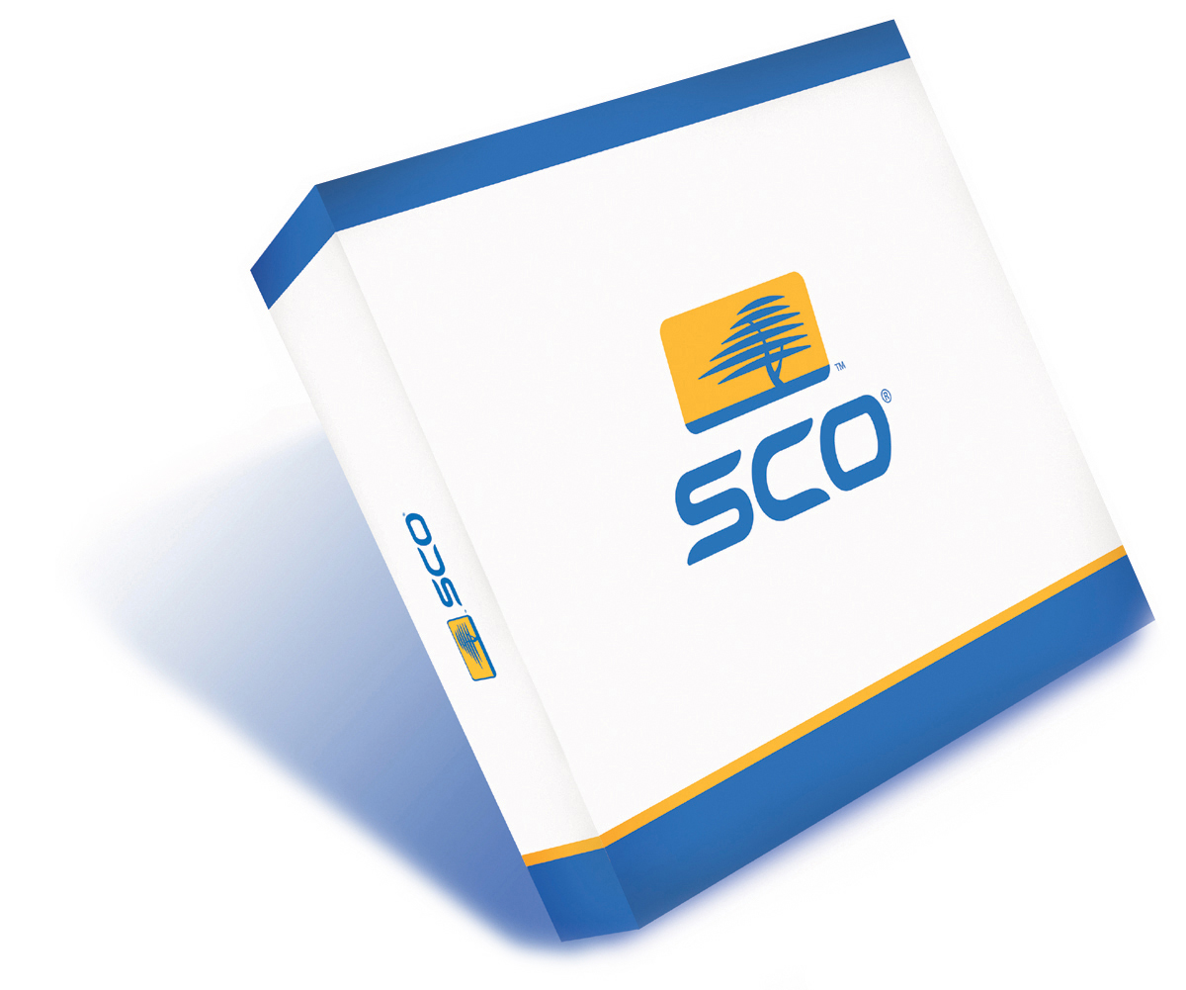
SCO OpenServer Release 6:

- Gets work done faster
  - More than double the performance
of previous versions
  - Multi-processing capabilities:
increased from 4 to 32 processors
  - Increased Memory Support–up to 64 GB
  - Dynamic loadable drivers
- Handles greater workloads
  - Larger file support up to 1 Terabyte
- Works with thousands of UNIX applications, as well as:
  - Thousands of applications written for MySQL, PostgreSQL, Apache, Tomcat, and the latest version of Java
  - SCO’s Web Services Substrate technologies are integrated to make “green screen” applications available in a Web environment
- Works in a secure environment
  - Includes latest security enhancements, including: SSH, IP Filter, IPsec, File System Access Control Lists, and Encrypted File Systems

New Features and Benefits
Features | Benefits
Multi-Threaded Kernel | By incorporating SVR5 technology into OpenServer Release 6, this kernel now has support for more modern applications.
Large File Support | OpenServer Release 6 includes large file support (up to 1 Terabyte) that enables it to drive more modern and powerful applications.
Multi-Processor Support | OpenServer 6 has increased multi-processor support from 4 to 32 processors, taking advantage of the power of more modern and up-to-date hardware. SVR5 is a hardened kernel that runs on low cost, industry standard servers and is capable of near-linear scaling as resources are added to the system.
Increased Memory Support | Memory support increases from 4 GB to 64 GB in OpenServer 6. This enables the product to run and support more powerful applications and hardware.
Speed and Performance | The SVR5 kernel enhancements in OpenServer 6 have produced significant improvements in speed and performance. Some OpenServer applications are reporting a 400% speed improvement with version 6.
Improved support for Asynchronous I/0 | AIO enables even a single application thread to overlap disk read/write operations with other processing, thereby allowing useful work to be done while I/O is occurring in the background.
Dynamic Loadable Drivers | Drivers can be loaded or unloaded on a running system with no reboot required. This allows hot-plug of new peripherals such as a tape drive.
Includes KDE | With the addition of KDE, OpenServer 6 now has a modern, full-featured desktop, enabling a greater ease of use.
Hot-Plug Memory Support | With OpenServer 6 additional memory can be added into the system without a system reboot.
Fibre Channel-based SAN Support | OpenServer 6 comes with Fibrechannel-based SAN support for HP MSA 1000 systems. SCO supports QLogic Fibre Channel 22xx/23xx controllers.
VXFS Filesystem | High performance VXFS filesystem is journaled, ensuring data integrity in case of a hardware crash.
Hardware RAID Support | SCO OpenServer 6 supports the following RAID systems: Adaptec hardware RAID controllers, HP/Compaq RAID controllers, Intel Integrated RAID, LSI MegaRAID, and LSI Fusion-MPT RAID.
USB Printer Support | SCO OpenServer 6 supports USB printers.
DVD Backup Support | With OpenServer 6, businesses can utilize DVD backup systems, enabling faster and more cost effective backup of valuable data.
Supports UnixWare® 7.1.4 Applications | With the SVR5 kernel technology embedded in OpenServer 6, UnixWare applications are fully supported.
Serial Attached SCSI (SAS) for HP Proliant Products | SAS is the next generation of host controllers, and will replace slower parallel technologies, as well as control for the first time both Serial ATA and Serial Attached SCSI hard drives.
Native SATA | OpenServer 6 features full support for Intel's open Advanced Host Controller Interface (AHCI) specification which includes features such as Native Command Queuing and Hot-Plug support.
SCO's Assessment and Migration Services | Specifically designed for OpenServer 6, these services enable customers to make the most efficient use of their IT staff. These options will also be found beneficial in implementing SCO solutions that optimize productivity by leveraging the new and greatly improved features of the operating system.
IPsec | Encrypts all TCP/IP packets for security, and implements Virtual Private Network (VPN) functionality.
OpenSSH and OpenSSL | These network protocols allow for logging into and executing commands on a remote computer. They provide secure encrypted communications between two untrusted hosts over an insecure network.
Ipfilter for Firewall and NAT Functionality | Ipfilter technology allows OpenServer 6 to be configured as a firewall.
Kernel Privileges | The SVR5 kernel provides a fine-grain privilege mechanism. Using fine-grain privileges, the system can grant a subset of root powers to binaries, allowing them to achieve specific objectives without exposing the system to potential abuse/exploits.
Auditing of Events | Auditing enables the system administrator to record system events in a log and play back the audit trail to determine who did what and when.
Supports NFS v3 with TCP | Network File System (NFS) is an industry standard protocol for sharing files across networks. NFS v3 adds support for large files and NFS over the TCP protocol.
Encrypted File System and Archives | This file system encrypts data stored on the disk. The data can then be de-crypted using private keys.
Emergency Recovery CD-R/RW Media Support | Emergency recovery enables the system administrator to create bootable CD-R/RW media for disaster recovery.
Centrino™ Wireless Technology | Centrino is an Intel wireless technology standard supported by SCO. With this new technology included in OpenServer 6, laptops now have fully integrated wireless LAN capability without the need of a wireless plug-in card for excellent mobile performance.
PRISM Technology | A wireless hardware connectivity standard supported by SCO. This is what Centrino communicates with. A wireless router, a print server can communicate through a wireless network regardless of the data payload being transmitted. With these technologies, a wireless device can send documents to a printer.
Apache version 1.3 | OpenServer 6 includes the popular open source Apache web server.
Mozilla 1.7 and Java Plug-ins | Release 6 includes the 1.7 release of the popular Mozilla web browser.
Tomcat | Tomcat enables OpenServer 6 to run and display Java applets. Tomcat is an open source implementation of JavaServer Pages and Java Servlets. JSP and Java Servlets are the Web presentation layer in Java 2.
SCO File and Print Server with Samba 3.013 | Samba provides file and print interoperability services between UNIX and Windows clients.
MySQL Database | UNIX customers are ever increasingly looking for database alternatives. MySQL, a good and cost-effective alternative to other popular databases, is included with OpenServer 6.
PostgreSQL Database | PostgreSQL is also included for customers looking for alternative database solutions with SCO OpenServer 6.
Supports Virtualization Languages - PHP and Perl | OpenServer 6 includes popular development tools Perl and PHP for rapid application development.
Single Certification for Applications and Drivers | With OpenServer 6, an ISV can develop to either UnixWare 7.1.4 or OpenServer 6 and certify on both. With the same kernel, now applications and drivers can run seamlessly on both platforms.
Wide Hardware Support | OpenServer 6 includes support for USB, AC97, SATA, SAS, IDE RAID, FC SAN, PCIX and others.
Java 1.4.2 | SCO OpenServer 6 supports the Java 2 platform, Standard Edition for running Java code.
Supports Thousands of Applications | SCO OpenServer 6 will run thousands of applications written for SCO UnixWare and SCO OpenServer.
Full Backward Compatibility, Including Xenix Application Support | Small businesses have invested considerable money in hardware. With OpenServer 6, SCO supports applications all the way back to Xenix 286 applications.

System Requirements

Technical Overview
SCO OpenServer Release 6 is specifically designed to address the need to modernize the SCO OpenServer operating system—with an intense focus on adding support for kernel-level threads and large files. To achieve these requirements, SCO has replaced the existing SCO OpenServer kernel with the SCO SVR5 kernel. SCO OpenServer Release 6 also gives users the option of using the latest KDE graphical desktop or they can use the traditional SCO OpenServer Desktop, also known as the traditional X-Windows/CLI interface.

This kernel improvement dramatically improves the speed and performance of OpenServer. It also meets a growing customer need for larger file size support (up to 1 Terabyte) and greater memory support. This change also allows OpenServer customers to gain a broader exposure to UnixWare applications. A key element of this release for ISVs and IHVs is the ability to “single certify” on one operating system and function on both.

System Requirements
Hardware | Minimum | Recommended | Maximum
CPU | A single Intel® Celeron®, Pentium®, Pentium II, Pentium II Xeon™, Pentium III, Pentium III Xeon, Pentium 4, or Intel Xeon microprocessor, or a microprocessor that is 100% compatible (e.g., AMD Athlon™, Athlon 64, Duron™, Sempron™, or Opteron™ processor) | Pentium P4 | 32 CPUs
Memory | 64MB of Random Access Memory (RAM) is required. For running graphically-intensive applications like Java or KDE, a minimum of 128 MB of RAM is required | 256MB. | 64GB
Disk Space | To install all packages included in the media kit, 4GB of disk space is required. Small footprint installations can run on partitions as small as 1GB. | 8GB | 1TB (per disk)
HBA | IDE | SCSI, SATA, or SAS | 1024
Other | Requires a CD-ROM and a BIOS that supports booting from the CD-ROM, keyboard, and monitor | Mouse, NIC, and 1.44MB floppy drive

Hardware Requirements
The hardware that you will need to support an installation of OpenServer 6 will vary depending on the installation options you choose. All installations have the following minimum requirements:
Processor
At least one Intel® Celeron®, Pentium®, Pentium II, Pentium II Xeon™, Pentium III, Pentium III Xeon, Pentium 4, or Intel Xeon microprocessor, or a microprocessor that is 100% compatible (e.g., AMD Athlon™, Athlon 64, Duron™, Sempron™, or Opteron™ processor). A Pentium P4 or one of higher performance is recommended, up to 32 CPUs are supported.
Memory
A minimum of 64MB of Random Access Memory (RAM) is required. For running graphically-intensive applications like Java or KDE, a minimum of 128 MB of RAM is required. 256MB of memory is recommended and up to 64 GB is supported.
Disk Size and Partitions
A hard disk of 4GB is needed to install all the packages included in the media kit. Small footprint installations can run in partitions as small as 1 GB. An 8GB disk is recommended and disks up to 1TB are supported.
Additional space will be needed for data and user files.
Mouse
A serial, USB, or PS/2-compatible mouse is recommended to access all graphical desktop functionality.
HBA
At least one IDE, SCSI, SATA or SAS Host Bus Adapter (HBA) is required, and up to 32 HBAs are supported by default. Additional HBAs (up to a maximum of 1024) can be added; however, the driver for any HBA added above 32 must support such a configuration.
Video
A Super VGA monitor and video adapter capable of at least 1024x768 resolution is required to run the graphical desktop. Systems running Merge from the Optional Services CD will require a 1280x1024 16-bit (or better) graphics adapter. The graphics adapter used during a fresh installation must have an IBM VGA compatible mode.
Network Card
At least one NIC is required for networking; up to 4 NICs of the same manufacturer and model can be connected at one time.
Media Devices
A 3.5-inch diskette is recommended and is required if:
- You want to perform an installation from the media kit CD-ROMs and your system does not support bootable CD-ROMs.
- You need to install vendor-supplied software (such as device drivers) from diskettes.

Getting Started

SCO OpenServer Release 6 Installation Overview
The SCO OpenServer 6 installation takes place in five phases:
- Initial boot and hardware detection
- Interactive Query Manager (IQM) collects configuration information from the user, including:
  - Licensing, installation media device, and upgrade path information
  - System level information
  - Disk setup and software selections
  - Final configuration information
- Hard disk initialization and preparation
- Filesystem creation
- Software installation
Only phases 1 and 2 require user interaction. The last two phases, where the system is actually installed, are usually the most lengthy: 10 to 20 minutes on new hardware; 1 to 1.5 hours on old hardware.

To Install SCO OpenServer 6:

- Boot your computer using the OpenServer 6 CD.
- The initial OpenServer 6 licensing screen will appear. Press Enter to continue.
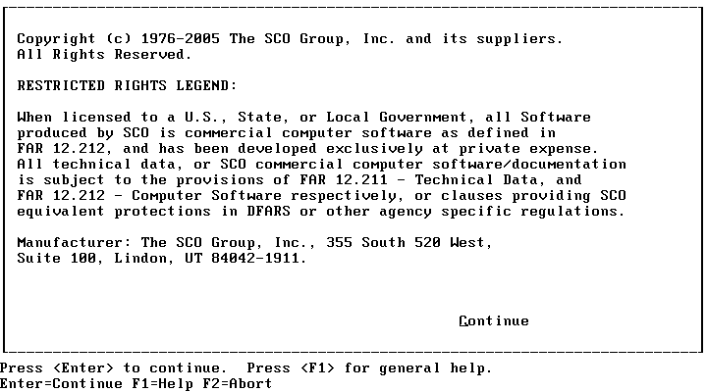

- The Welcome screen will then appear. Press Enter to continue.

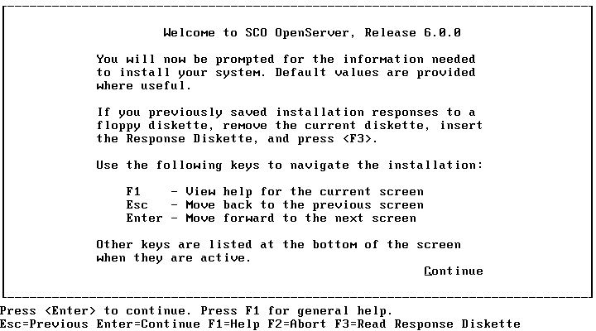

- An acceptance licensing screen will then appear. We invite you to read the license and then choose Accept to continue.

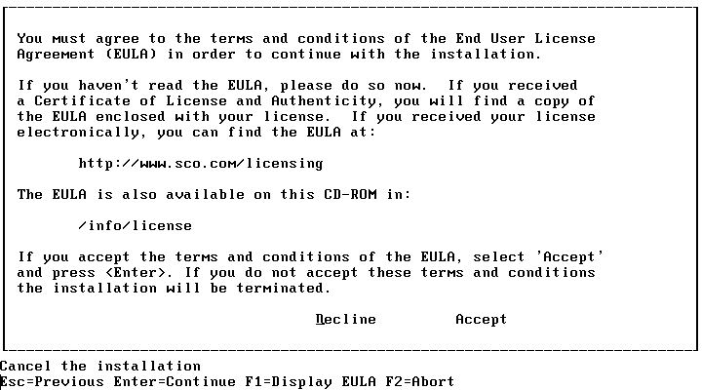

- The HBA (Host Bus Adapter) screen will then appear. If you do not have any HBA drivers to load, leave the default at “no” and choose Accept above choices to continue.
NOTE: The bottom of the screen outlines a number of navigation options.

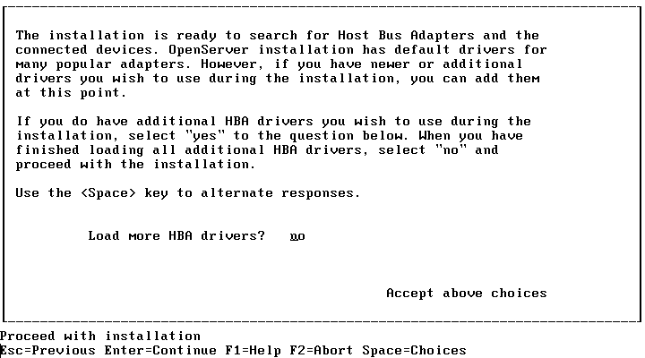

- The system will now load the default HBAs from the CD media.

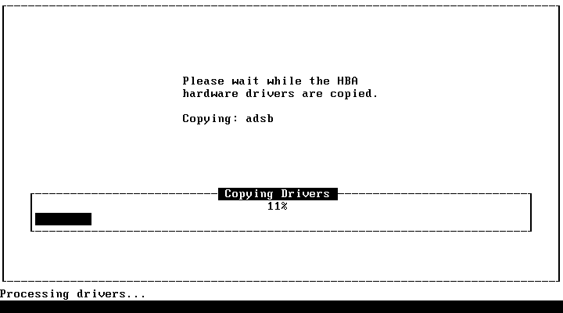

- In the following screen, leave the default of “All Drivers Selected”, and select Accept above choices to continue.

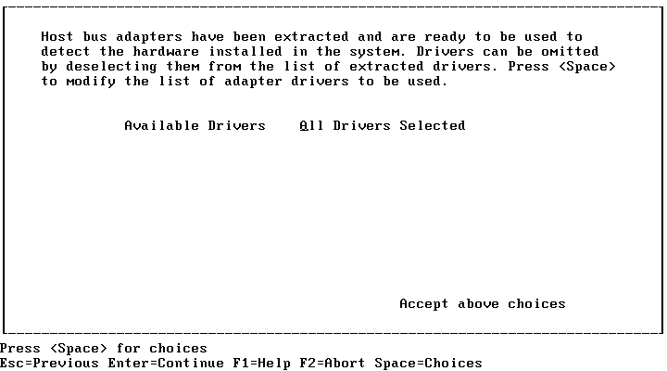

- In the following screen, leave the default choice of “Install from CD-ROM”, and select Accept above choices to continue.

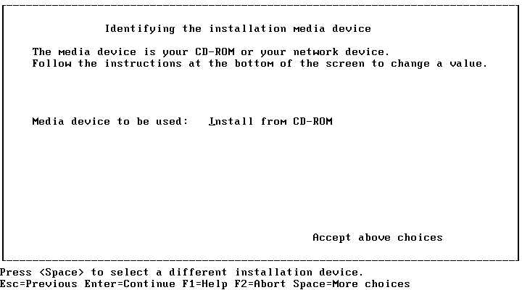

- In the Selecting Keyboard Type screen, select the appropriate keyboard option using the navigation options listed at the bottom of screen. Select Accept above choices to continue.

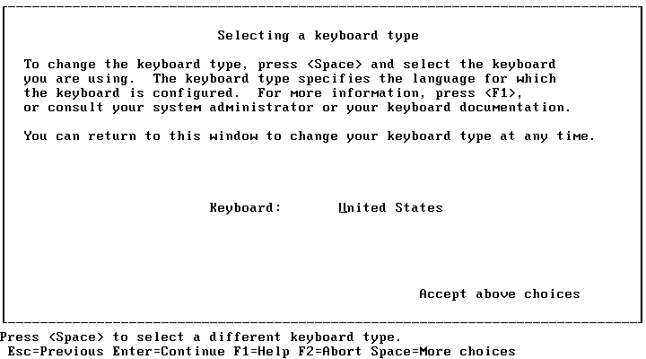

- In the Licensing Your System screen, enter in the following license information:
Press F8 to use the temporary evaluation license. .

Select Accept above choices to continue.

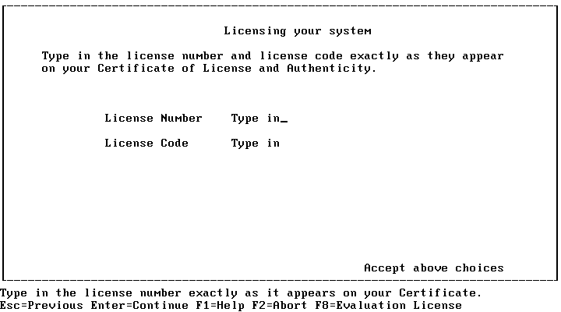

- In the Configuration screen, enter your server name, domain name, security profile, time zone, and language using the navigational options at the bottom of screen and select Accept above choices to continue.

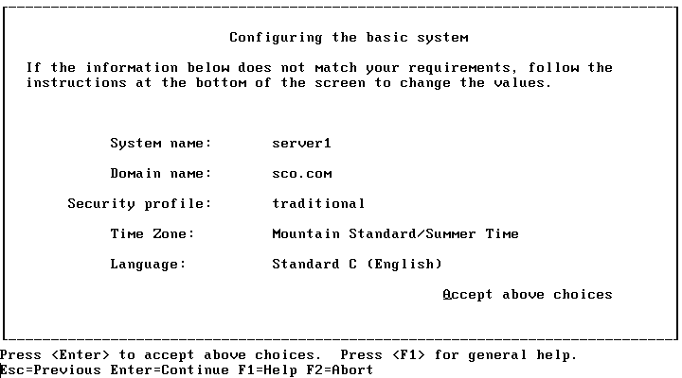

- In the Choosing Software screen, apply the defaults listed for this review. Select Accept above choices to continue.

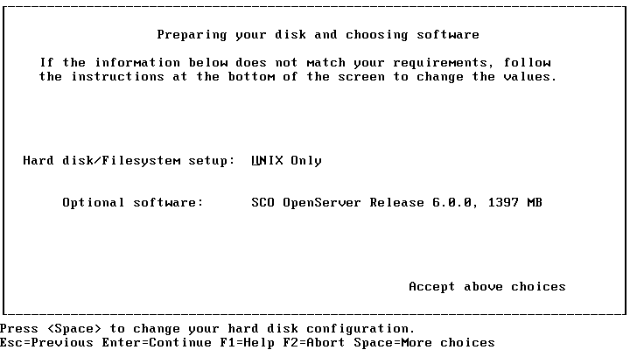

- In the Optional Software screen, press Enter to have the installation process autodetect your network card. Using the navigational options on the bottom of the screen, complete the process of configuring your network address, video, graphics and mouse.
Select Accept above choices to continue.

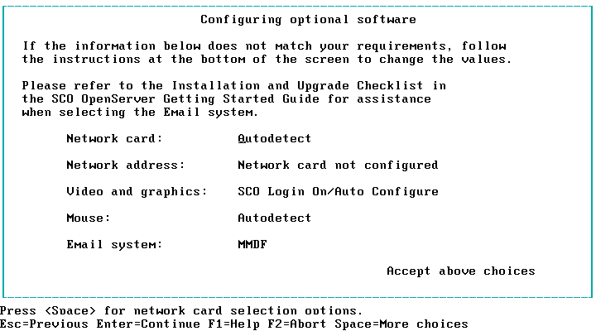

- If the Network address is not configured, select that option and open the Configuring your network screen. This step will allow you to configure your system based on your current Network address. Select Accept above choices to continue.

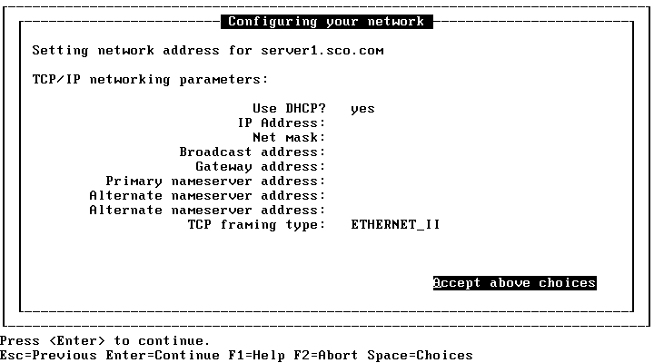

- Again, the Email System MUST be to SendMail for this review.

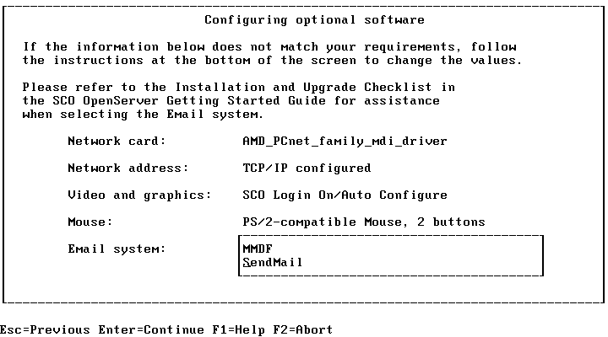

- In the Setting Root Password screen, enter a new password for the root (admin) account and confirm.
NOTE: Please make a note of the root password you choose to enter. This password will be required at a later point in the review. The “Repeat root password” field will appear after the initial “Root password” is entered.
Select Accept above choices to continue.

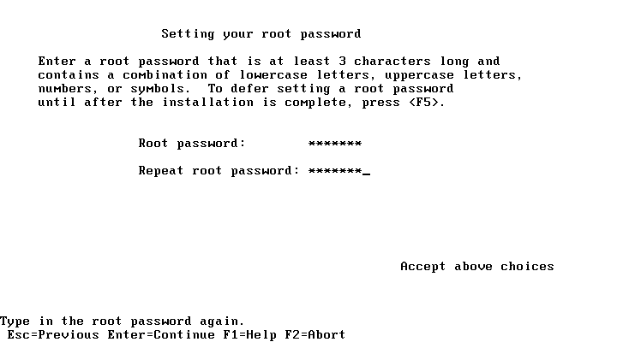

- In the following screen, please ensure that you are satisfied with your answers during setup. Then select Accept above choices to continue.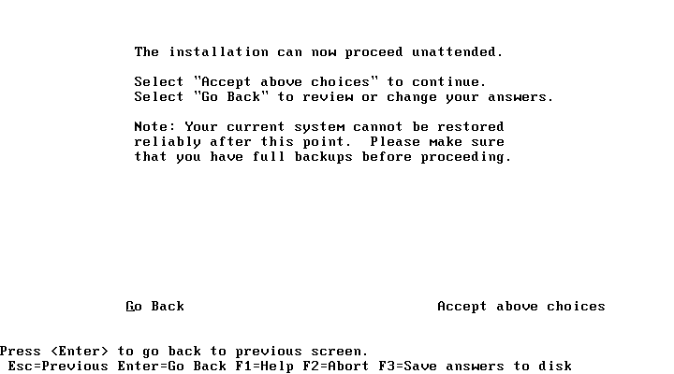

- The installation of the OpenServer 6 operating system will now begin.
NOTE: Please make note that the entire installation process will likely take more than 60 minutes to complete.

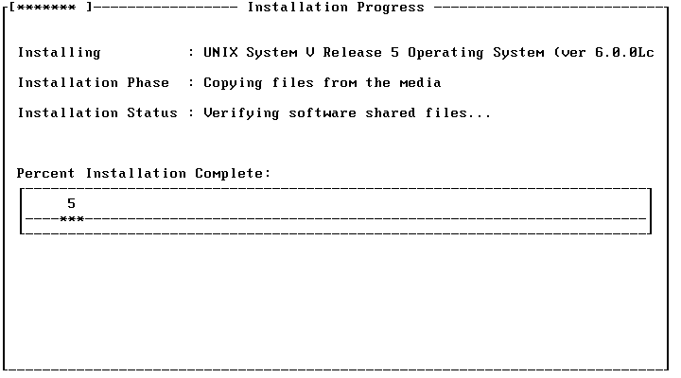

- The following screen provides additional detail on SCO OpenServer 6 installation and configuration.

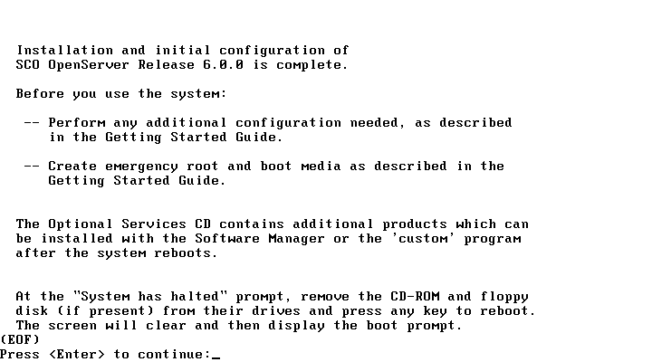

You have now completed the process of installing and configuring SCO OpenServer 6.

To Open the SCO OpenServer 6 Login Screen:

- Remove the SCO OpenServer 6 CD from the CD-ROM drive and press Enter. The system will begin to load SCO OpenServer 6.
- Press “any key” to continue when prompted by the system. The system will then run through some initial configuration screens and open the SCO OpenServer 6 Login screen.

The review will now focus on some of the new features of SCO OpenServer 6, including the new KDE desktop environment, Java Web application support, encrypted filesystem support and large file support (above 2 Gigabit).

OpenServer KDE
The KDE is a desktop environment that provides a modern computing interface, comparable to the look and feel of Microsoft Windows XP. The KDE contains a collection of programs, technologies and documentation that moves away from the classic mode of past OpenServer releases, called XDT3.

In this section, we will showcase the new KDE in SCO OpenServer 6.

To Change from Classic OpenServer XDT3 to the New OpenServer KDE:

- At the SCO OpenServer Login screen, log onto the system by entering root in the server login field.
- In the Password field, enter the root password that you assigned/created during the installation process.
NOTE: Password characters will not appear in the Password field for security reasons.
- Click Login. The classic OpenServer XDT3 desktop environment will appear.
- Double-click the Edit icon that is on the desktop. An editor window will appear.
- Select File→ Open in the Edit window. The Open dialog box will appear.
- In this dialog box, double-click //etc in the Directories list. Then double-click /default in the Directories list.
- In the Files list, double-click X11. A new file will then appear in the Edit window.
- In the Edit window, change XDESKTOP=xdt3 to XDESKTOP=kde3.
- From the File menu, select Exit and then click Save in the message box provided.

To see the new KDE desktop environment in SCO OpenServer 6, you must logout of the existing desktop environment and re-log into the SCO OpenServer 6 system.

To Log Out of the OpenServer XDT3 Desktop Environment:

- From the File menu, select Exit.
- Click OK in the message box provided.

To Log into the SCO OpenServer KDE Desktop Environment:

- At the SCO OpenServer 6 Login screen, log onto the system by entering root in the server login field.
- In the Password field, enter the root password that you assigned/created during the installation process.
NOTE: Password characters will not appear in the Password field for security reasons.
- Click Login.
The initial launch of the SCO OpenServer 6 KDE desktop environment will ask the user to assign specific preferences. For this review, we recommend simply using the Default options provided in the Desktop Settings Wizard. These preferences include:

- Country
- Language
- GUI Behavior (Windows, Mac, UNIX, etc.)

- KDE Performance Tuning
- GUI Themes

Once you’ve completed the KDE Desktop Settings Wizard walkthrough, the SCO OpenServer 6 KDE desktop environment will now appear. It should be noted that the default screen resolution for the KDE desktop environment is set at the highest resolution supported by your system.

To Change the Screen Resolution:

- Click the K icon in the lower-left corner of the navigation bar, select System→ Screen Resize & Rotate. A new Screen Resize & Rotate icon will appear in the lower-right corner of the navigation bar.
- Click on the Screen Resize & Rotate icon and select Configure Display. The Configure Display dialog box will appear.
- In this dialog box, check Apply settings on KDE startup and Allow tray application to change startup settings. Click OK.
- Click on the Screen Resize & Rotate icon again and select the preferred screen resolution. (We recommend selecting at least 1024 x 768 for this review.)
- In the Confirm Display Settings Change – Resize dialog box, click Accept Configuration to make the change. NOTE: If you do not accept the configuration selected in the time specified, you will need to repeat steps 4 and 5.

You have now completed the process of changing from an SCO OpenServer XDT3 desktop environment to the new SCO OpenServer 6 KDE desktop environment. You have also adjusted the screen resolution.

Java (Web Application) Support
OpenServer 6 now works with the latest web-enabling technologies, like Java. SCO understands the importance of these new web technologies, and now supports Java 1.4.2 development. Java 1.4.2 currently ships with a number of different demo applications included within the application. In this section, we will launch one of the demo applications shipped with Java 1.4.2.

To start up an existing Java application:

- Click the K icon in the lower-left corner of the navigation bar, select Run Command. The Run Command dialog box will appear. Enter the following command in the Command field provided:

/opt/java2-1.4.2/bin/java –jar /usr/java/demo/jfc/Java2D/Java2Demo.jar
NOTE: It’s important to recognize that there are two spaces in this file path (java –jar ) and multiple capitalizations used.

- Click Run. The Java 2D Demo window will appear and display a running Java application.
- Click on the tabs provided in the Java 2D Demo window (Clippings, Colors, Fonts, Images, etc.). There are numerous examples of Java applications supported by SCO OpenServer 6 running within this window.
- Once you’ve completed reviewing the Java applications provided, select Exit in the File menu.
You have now seen some of the Java support features in SCO OpenServer 6.

Encrypted File Systems

SCO OpenServer 6 provides users with the ability to encrypt/decrypt data used in AES 128-Bit file systems. Encrypted file system data protects the user or organization from unauthorized data usage.

For this review, we will outline the process of encrypting/decrypting files in SCO OpenServer 6. It should be noted that the encryption/decryption process is transparent to the user. During this process, we will set up file encryption, set permissions, create a mount point, assign a variable, create the file system and mount the file system.

This process will showcase some of the safety and security features used to encrypt AES 128-Bit file systems in SCO OpenServer 6.

To Setup an Encrypted File:

- In the KDE desktop environment, click on the UNIX icon. The UNIX terminal window will appear.
- In the terminal window, change to the root directory using the command cd /.
- At the root directory, enter “touch encrypted.file” (with quotation marks included) to create a file that will be eventually used as an encrypted file system.
NOTE: For this exercise, we will use the file name “encrypted.file”. However, any file name can be used.
- Press Enter. The encrypted.file will be automatically created.
- To verify that the encrypted file was created, type ls –l encrypted.file and press Enter. The encrypted.file will appear in the listing.

To Set the Appropriate Permission on the Encrypted File:

- In the terminal window, type chmod 660 encrypted.file to change the permissions for the newly created file.
NOTE: For this example, we will set the newly created file permissions to 660. This will grant read/write privileges to the owner and the group.

- Press Enter.

To Create a Mount Point Directory:

- In the terminal window, type mkdir /encrypt to make a directory that will act as a new mount point.
NOTE: This example will create a mount point off of the “root” directory.
- Press Enter. The new mount point directory (encrypt) will be automatically created.
- To verify that the new mount point directory was created, type ls –ld /encrypt and press Enter. The /encrypt directory will appear in the listing.

To Set the Appropriate Permission on the Mount Point Directory:

- In the terminal window, type chmod 750 /encrypt to change the permissions for the newly created mount point.
NOTE: For this example, we will set the newly created mount point directory permissions to 750. This will grant read/write/execute privileges to the owner and read/execute privileges to the group.
- Press Enter.

To Assign the Output of the Marry Command to a Variable

- In the terminal window, type

cryptfs=`marry –a –b 10005 –c “builtforsecurity” /encrypted.file`
- Press Enter.
NOTE: In this example, the output of the “marry” command is assigned to the cryptfs environment variable; this is done only to simplify typing the commands in the next step.

To Create a File System within encrypted.file:

- In the terminal window, type
mkfs –F vxfs $cryptfs 10000
- Press Enter. A WARNING message will appear outlining specific instructions for file system creation.

- At the WARNING message, type “y” and press Enter. A Veritas filesystem will be automatically created in the encrypted file.
To Mount the Newly Created File System to the Mount Point:

- In the terminal window, type
mount $cryptfs /encrypt
- Press Enter. The encrypted file system was automatically created. This encrypted file system was also mounted to the directory /encrypt. To view the newly created encrypted file system, change the directory (using the cd command) and verify that the encrypted file system has been successfully mounted by using the mount command. All data stored under /encrypt directory is now secured with 128 Bit encryption.
- From the File menu, select Exit to close the terminal window.

You have now successfully created an encrypted file system with SCO OpenServer 6.

1 TeraByte File Support

SCO OpenServer 6 now provides users with 1 TeraByte file support. A TeraByte is equal to approximately 1 trillion bytes. This new feature allows SCO OpenServer 6 users to create files that are over the previous 2 gigabyte file limit in older versions of SCO OpenServer. This new feature provides greater flexibility in file size and application usage.

To showcase this new feature, we will create a file that is larger than 2+ Gigabytes. In order to accomplish this task, we will need to use SCO OpenServer 6 large filesystem-aware commands. These commands can be found in /u95/bin.

To Create a 2+ Gigabyte File:

- In the KDE desktop environment, click on the UNIX icon. The UNIX terminal window will appear.
- In the terminal window, type

/u95/bin/dd if=/dev/urandom of=bigfile bs=100k count=40000
- Press Enter. A 4+ Gigabyte file will be created.
NOTE: This exercise will require approximately 5 minutes to complete. This test also requires approximately 5 Gigaytes of available disk space on your machine.

You have now successfully created a 2+ Gigabyte file in SCO OpenServer 6. This completes the detailed instructions for the product walkthrough. Feel free to investigate other features within SCO OpenServer 6.

Pricing and Support
In SCO OpenServer 6, SCO has revised the default configurations to provide more value along with new features contained in this latest release. The following table summarizes the SCO OpenServer 6 Edition configurations.

Edition | Starter | Enterprise
Price | $599 | $1,399
Users | 2 | 10
CPUs | 1 | 4
Memory | 1GB | 4GB

New Optional Bundled Support
SCO OpenServer 6 introduces optional support bundles providing customers with the convenience to purchase product bundled with basic break-fix support at reasonable cost. The service is designed to offer a streamlined low cost option with built-in flexibility. It allows for the ability to either add individual components to tailor customers’ business requirements, or, upgrade to one of the higher end options available from SCO’s award winning Support Services.

The support bundled with selected OpenServer 6 Editions includes the following services:
- Traditional “Break-Fix” support for six months
- Per Installation/server
- Four Business Hour Response
  - Phone, E-mail, Fax or Web – Option to Uplift
- Two Authorized Technical Contacts

Customers wishing to add to the bundled services have the following options:
- 24 X 7 Emergency Service
- Retired Products
- One Business Hour Response Time
- Layered Product Add-on
- Upgrades to TEAM, SoftTech or SoftTech Plus

The following models are standard New, Upgrade and Trade-in Licenses for OpenServer 6 which include six months of support bundled in. Prices are introductory until 31 December 2005 after which price increases will take effect.

OpenServer 6 Editions With Bundled Support* | License Pack | Web License | US$ List
OpenServer 6 Enterprise Edition - 10-User, 4-CPUs, 4GB with Support | LA262-UX00-6.0 | LA262-UX00W-6.0 | $2,499
OpenServer 6 Starter Edition - 2 Users, 1CPU, 1GB with Support | LA252-UX00-6.0 | LA252-UX00W-6.0 | $1,699
* Standard Edition Licenses with 6 months of SCO Support bundled in.

Upgrades to OpenServer 6 From OpenServer 5.0.7 With Support | License Pack | Web License | US$ List
To OpenServer 6 Enterprise from OpenServer 5.0.7 Enterprise | LX262-2600-6.0 | LX262-2600W-6.0 | $1,549
To OpenServer 6 Starter from OpenServer 5.0.7 Host | LX252-2400-6.0 | LX252-2400W-6.0 | $1,299
To OpenServer 6 Starter from OpenServer 5.0.7 Desktop | LX252-2200-6.0 | LX252-2200W-6.0 | $1,299
To OpenServer 6 Enterprise from OpenServer 5.0.7 Host | LX262-2400-6.0 | LX262-2400W-6.0 | $1,949
* Standard Upgrades from OpenServer 5.0.7 with 6 months of SCO Support bundled in

Upgrades to OpenServer 6 From OpenServer 5.0.6 With Support | License Pack | Web License | US$ List
To OpenServer 6 Enterprise from OpenServer 5.0.6 Enterprise | LX262-2601-6.0 | LX262-2601W-6.0 | $1,699
To OpenServer 6 Starter from OpenServer 5.0.6 Host | LX252-2401-6.0 | LX252-2401W-6.0 | $1,449
To OpenServer 6 Starter from OpenServer 5.0.6 Desktop | LX252-2201-6.0 | LX252-2201W-6.0 | $1,449
To OpenServer 6 Enterprise from OpenServer 5.0.6 Host | LX262-2401-6.0 | LX262-2401W-6.0 | $2,199
* Standard Upgrades from OpenServer 5.0.6 with 6 months of SCO Support bundled in

Current/Previous Customer Trade-Ins With Support | License Pack | Web License | US$ List
OpenServer 6 Enterprise from OpenServer Enterprise 5.0.5 or earlier, SCO OpenDesktop, SCO Unix, SCO Xenix plus support | LX262-UX00-6.0 | LX262-UX00W-6.0 | $1,849
OpenServer 6 Starter from OpenServer Host Release 5.0.5 or earlier, SCO OpenDesktop, SCO Unix, SCO Xenix, plus support | LX252-UX00-6.0 | LX252-UX00W-6.0 | $1,499
OpenServer 6 Starter from OpenServer Desktop 5.0.5 or earlier, SCO OpenDesktop, SCO Unix, SCO Xenix, plus support | LX252-UX10-6.0 | LX252-UX10W-6.0 | $1,499
* Standard Trade-ins with 6 months of SCO Support bundled in

Global Services and Support
SCO's award-winning Global Services offer a complete portfolio of world-wide services on SCO's full range of software products, allowing customers powerful choices based on business requirements.

Technical Support
SCO offers a wide array of technical support services ranging from business critical, 24x7 after-hours offerings to traditional support services covering all products and customer types from partners to end users. In addition, SCO support services are available to partners for their own use and resale.

SCO TEAM Support is designed for corporate customers requiring immediate, high-level, technical support. Included with TEAM is an assigned senior technical account manager to your company, responsible for assuring successful solution implementation and ongoing support for your SCO systems.

SCO SoftTech Plus includes support for unlimited licenses and installations covering all SCO products, with a guaranteed one-hour response time. This service is targeted to SCO partners and customers that need coverage for all SCO products. With SoftTech Plus, you also have an assigned administrative account manager as your primary contact for administrative issues.

SCO SoftTech includes support for unlimited licenses and installations with a guaranteed up to one-hour response time. SoftTech is available per operating system/product, allowing you the flexibility to add on additional products and services when you need them. Your administrative account manager provides a single point of contact for your administrative issues.

Professional Services
SCO's Professional Services offer a full suite of consulting services ranging from server deployment and management, migration and web services to customized solutions. For more information on Professional Services, visit http:/www.sco.com/consulting, or contact your local SCO sales representative.

For more information on SCO Global Services, call:

- In the Americas, phone 1-800-726-6561 or 1-831-427-6722
- Outside of the Americas, phone +353 1260 6333

Online Support Services

SCO also provides extensive 24x7 Self-Help technical support services on SCO products, including installation and configuration support through an easy-to-use, single Web view. The Self-Help Web site is located at: www.SCO.com/support/self_help.html.

More Information
For more information about SCO OpenServer 6, please visit our Web site at www.sco.com/products/openserver6.

Press Contact
Blake Stowell
Public Relations Director
+1-801-932-5703
bstowell@sco.com

Competitive Advantage

Reliability continues to be the most important SCO OpenServer 6 differentiator. SCO OpenServer is known for its phenomenal stability and quality. A recent IDC survey of 1000 IT professionals found UNIX to be superior to Linux in multiprocessing, integration, security, and skills availability. Overall, the survey found UNIX was more likely to meet expectations for features, overall performance and manageability. Additional competitive advantages are low Total Cost of Ownership, established reseller relationships, and a profitable reseller business model.

SCO OpenServer 6 stacks up well against the competition. For example:

Microsoft
SCO’s largest OpenServer 6 competitor is Microsoft Windows. IDC’s most recent report shows Microsoft with 55% market share of worldwide server operating system units. Microsoft operating systems dominate the industry and are present in all SCO customer channels and accounts. According to IDC, Microsoft products are known throughout the industry for their ease-of-use, broad device support, and broad application support.

Resellers and SMB customers are increasingly dissatisfied with Microsoft licensing and software assurance programs, product complexity, high hardware costs, poor security record, and upgrade cycles. Resellers are also dissatisfied with Microsoft channel management including decreasing margins, technical support and Microsoft programs shifting end-users to direct sales. SCO products and marketing initiatives take advantage of these competitive weaknesses by offering a stable, low-cost, highly secure product.

Red Hat and SuSE Linux
Linux server sales accounted for 23% of revenue-bearing server units reported to IDC. Linux has primarily been used for infrastructure such as web servers and file and print services. However, it is beginning to grow dramatically in the enterprise space. Red Hat is the leading Linux vendor with 69% market share.

Linux advantages are low cost, extensive components, and usability and an increasing number of supporting applications, including enterprise-level apps. However, recent pricing changes increase Linux total cost of ownership, eroding Linux cost advantages. The 2.6 release of Linux is characterized by major improvements in reliability and scalability along with improved device support. Legalities permitting, Linux will be used extensively for embedded devices and infrastructure services. IDC believes it will also become a major player in the application server space.

Other UNIX Flavors
UNIX operating systems account for 14.6% percent of server operating system units reported to IDC. UNIX continues to play an important role in the server market wherever reliability, security, scalability, and compatibility with existing applications is important.

According to IDC, the dominant UNIX hardware vendor for 2003 was IBM (29%), followed by HP (28%), and SUN (14%). In most opportunities SCO does not face direct competition with other UNIX vendors as they are not Intel-based. Intel-based competition is Windows and Linux.

Target Markets

Target Environments
- Small Businesses – SCO’s current volume and future volume opportunity is in small businesses with 5-99 employees. An estimated 44% of SCO’s revenue is from small businesses. SCO’s channel has successfully reached this market for 25 years. This small business opportunity continues to be attractive because the market is not saturated. Competitors still face the barrier of building an appropriate channel to reach the market. Moreover, there are over 20 million small businesses worldwide, compared to only 183,000 medium businesses.
Accordingly, IDC reports that the majority of small businesses do not have a server today. IDC states that small businesses are buying their first servers for shared Internet access, shared printing, file sharing, storage and remote access. These companies adopt technology to improve efficiency and productivity, save money, or increase their competitive advantage. Small businesses want proven technologies with mainstream status, accompanying price declines, and customized solutions for their vertical markets. Gartner research indicates that small businesses continue to rely on solution providers and don’t care about buying leading brands. These characteristics increase SCO’s opportunity to succeed with small businesses.

- Medium-Sized Businesses – The medium-sized business segment comprised 11% of SCO product and service revenue. The medium-sized business market is more competitive since it is served by both the channel and direct sales from major vendors. SCO’s medium-sized business segment is a secondary priority due to lower revenue, dramatically fewer target customers, more competition, a preference for homogeneous IT environments, and interest in “safe” vendors. However, SCO’s focus on small business will continue to spill into medium business sales.

- Large Businesses – SCO products are sold to large companies through the channel, direct sales and OEMs. In fiscal year 2003, large businesses comprised $4.7M in channel sales, $10.6M in direct sales, and $4.3M, an estimated half of the $8.6M in OEM sales. Altogether this accounts for an estimated 37% of SCO product and service revenue.

Vertical Market Considerations
- Pharmacies (a subset of retail)
- Healthcare (doctors’ offices and hospitals)
- Retail/Wholesale

Primary Target
Small businesses: SCO’s current volume and future volume opportunity is in small businesses with 5-99 employees. An estimated 44% of SCO’s revenue is from small businesses. SCO also targets medium-sized and large businesses, but the primary

audience is the small business user. While the ultimate end user may be the SMB, SCO primarily focuses on channel partners who serve the SMB market.

Target Problems Solved
SCO OpenServer solves the following customer problems:

Business Problems | Business Needs
Both for ISV certification and end-user customer who wants to use UW apps on OpenServer | Need larger file size support for modern applications
Increased security enhancements | Need higher multi-processor support
Support for Mozilla | Need compatibility between OpenServer and UnixWare applications
Support for Samba and Apache | Need improved performance for increasingly complex business needs
Cannot share printers, faxes, and data for internal collaboration | Need legacy support for older application versions
Have lost data stored on a computer | Need larger memory support
Wasting or losing time running on slow, legacy hardware | Need support for Java
Wasting or losing time running on slow, legacy hardware | Need KDE graphical desktop for updated look and feel
Limited office space (for example, a local McDonald’s franchise doesn’t have much space under a counter) | Need a reliable, low cost, multi-function infrastructure server (for example: file/print sharing, routing, firewall, web, intranet, Internet access)
 | Need for application serving (for example: accounting, data backup, database)

Target Users
- IT managers with experience in UNIX/Linux
- Solution providers with experience in UNIX/Linux

Target Channels
- SCO vertical solution providers who integrate their hardware and software solutions with OpenServer and sell the combined solution to vertical customers.
- SCO resellers who provide solutions to branch offices and small-to-medium-sized businesses.
- SCO major accounts that use OpenServer in branch offices and as departmental servers.

Language Support
All localized materials are on the CDs. Language versions include portions of the OS and installation localized. Not all documentation is localized. Language versions are anticipated to ship within 30 days of the First Customer Ship (FCS) in English.

- English
- French
- German

Key Messages

The top six key messages of SCO OpenServer 6 are:

- SCO OpenServer provides customers with access to modern applications via UNIX SVR5 technology and therefore supports a broader array of applications for the UNIX on Intel customer.

- SCO OpenServer delivers single certification enabling less work for ISVs and more applications for customers.

- SCO OpenServer delivers significantly increased speed performance to UNIX on Intel customers.

- SCO OpenServer is backed by a decade of rock-solid stability and dependability.

- SCO OpenServer is an affordable all-in-one server for small-to-large businesses.

- SCO is the supplier of the world’s most popular UNIX operating system for the Intel platform.

